Encoding Text

Definition
# Source: AI Source: Provided by: [Data Path: Persons Table -> ID Column: 1, Name_En Column: Motasem Essam] -> From: [ChatGPT] on [12/10/2025]
Encoding Text is a text transformation technique that converts categorical or textual data into numerical representations so that machine learning algorithms can process it. Since most models cannot handle raw text, encoding is essential for text analysis and NLP applications.

Key Idea
# Source: AI Source: Provided by: [Data Path: Persons Table -> ID Column: 1, Name_En Column: Motasem Essam] -> From: [ChatGPT] on [12/10/2025]
Text is transformed into numbers using techniques that preserve meaning, frequency, or context. These numerical representations allow algorithms to analyze patterns, similarities, or relationships in text data.

Common Methods of Encoding Text

1. Bag of Words (BoW)
# Source: AI Source: Provided by: [Data Path: Persons Table -> ID Column: 1, Name_En Column: Motasem Essam] -> From: [ChatGPT] on [12/10/2025]
- Represents text as a vector of word counts.
- Each unique word becomes a feature/column.
- Example:
Original Text:
["Data science is fun", "Machine learning is fun"]
Bag of Words representation:
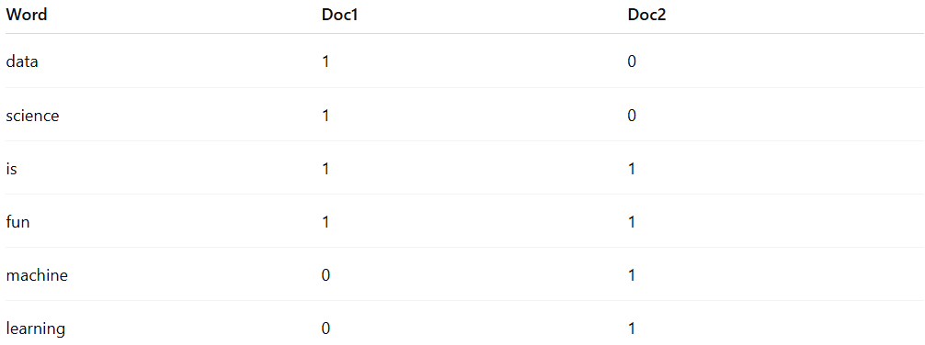
Word | Doc1 | Doc2
data | 1 | 0
science | 1 | 0
is | 1 | 1
fun | 1 | 1
machine | 0 | 1
learning | 0 | 1

2. TF-IDF (Term Frequency – Inverse Document Frequency)
# Source: AI Source: Provided by: [Data Path: Persons Table -> ID Column: 1, Name_En Column: Motasem Essam] -> From: [ChatGPT] on [12/10/2025]
- Assigns weight to words based on their importance in a document relative to the whole dataset.
- Helps downweight common words and highlight informative words.

3. One-Hot Encoding for Text
# Source: AI Source: Provided by: [Data Path: Persons Table -> ID Column: 1, Name_En Column: Motasem Essam] -> From: [ChatGPT] on [12/10/2025]
- Converts each unique word into a binary vector indicating presence (1) or absence (0).
- Suitable for small vocabularies.

4. Word Embeddings
# Source: AI Source: Provided by: [Data Path: Persons Table -> ID Column: 1, Name_En Column: Motasem Essam] -> From: [ChatGPT] on [12/10/2025]
- Maps words into a dense vector space that captures semantic meaning.
- Popular methods: Word2Vec, GloVe, FastText, BERT embeddings.
- Example: "king" might be represented as [0.23, -0.12, 0.87, …].

5. Label Encoding for Text Categories
# Source: AI Source: Provided by: [Data Path: Persons Table -> ID Column: 1, Name_En Column: Motasem Essam] -> From: [ChatGPT] on [12/10/2025]
- Converts categorical text labels into numbers.
- Example:
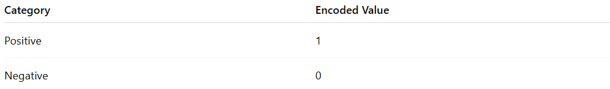
Category | Encoded Value
Positive | 1
Negative | 0

Example
# Source: AI Source: Provided by: [Data Path: Persons Table -> ID Column: 1, Name_En Column: Motasem Essam] -> From: [ChatGPT] on [12/10/2025]
Original dataset:

Review ID | Text
1 | "I love this product"
2 | "This product is terrible"
Bag of Words representation:
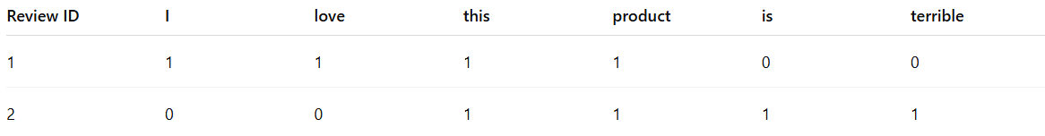
Review ID | I | love | this | product | is | terrible
1 | 1 | 1 | 1 | 1 | 0 | 0
2 | 0 | 0 | 1 | 1 | 1 | 1

Advantages
# Source: AI Source: Provided by: [Data Path: Persons Table -> ID Column: 1, Name_En Column: Motasem Essam] -> From: [ChatGPT] on [12/10/2025]
- Converts unstructured text into numerical features
- Enables machine learning and NLP models
- Preserves semantic meaning when using embeddings

Disadvantages
# Source: AI Source: Provided by: [Data Path: Persons Table -> ID Column: 1, Name_En Column: Motasem Essam] -> From: [ChatGPT] on [12/10/2025]
- BoW and One-Hot can create high-dimensional data
- Embeddings require large datasets and computational resources
- Context may be lost with simple encoding methods

